**H1 Front Matter**

H2: Predator reintroduction alters species interactions and stability in a kelp forest ecosystem

**H2:Authors**

Mark D. Scheuerell1*, Eric J. Ward2, Stephen L. Katz3

**H2:Affiliations**

1Fish Ecology Division, Northwest Fisheries Science Center, National Marine Fisheries Service, National Oceanic and Atmospheric Administration, Seattle, WA 98112.

2Conservation Biology Division, Northwest Fisheries Science Center, National Marine Fisheries Service, National Oceanic and Atmospheric Administration, Seattle, WA 98112.

3School of the Environment, Washington State University, Pullman, WA 99164.

*Correspondence to: mark.scheuerell@noaa.gov.

**H2:Summary**

Reintroduction of sea otters coincided with changes in species interactions and decreased stability of a kelp forest food web

**H2:Abstract**

Global-scale losses of apex predators have led to profound changes in community structure and ecosystem processes, but the effects of predator reintroductions on recipient ecosystems remains poorly understood. We examined a long-term data set from a kelp forest in the California Channel Islands to characterize how species interactions and stability change over time following the reintroduction of sea otters. We identified multiple interactions within the food web that changed coincident with the establishment of otters, including interactions consistent with the classic trophic cascade (effects of predators on grazers, and grazers on primary producers subsequent to otter establishment). By allowing species interactions to vary over time, we also found that stability decreased over time, which may have been initiated by fishing effects, but was ultimately sustained via increased otter numbers. Therefore, explicit consideration of the potential changes in the interactions among species following predator reintroduction, and their integrated effects on stability, may be more important than simply quantifying species abundance or diversity.

**H1 MAIN TEXT**

**H2:Introduction**

Top predators exert strong influences on ecosystems through direct predation and trophic cascades (*1, 2*), and yet a global pattern is emerging where large carnivores are consistently the first species lost as a consequence of human activities (*3, 4*). The loss of these apex predators effectively cuts off the top of the trophic pyramid, leading to trophic “skew” or “downgrading” and can cause disproportionate effects on community organization and biogeochemical cycles (*1, 4*). As a consequence of these changes, the response of the entire system to additional perturbations (i.e., its stability) may shift considerably, reducing the supply of ecosystem services and complicating management options (*5, 6*).

Given their strong ecological influence, top predators have also been the focus of recovery efforts via the establishment of protected reserves (*7*) and intentional reintroductions (*8*). In the case of predator reintroductions, the response of an ecosystem is sometimes predictable (*9*), but there are many counter examples where the introduction of top predators has had unexpected results (*10, 11*). Although the introduction of non-native species can offer some insights, the associated transformation of the ecosystem by these perturbations creates hybrid or novel conditions unrepresentative of the underlying evolutionary history (*12*). Thus, it is increasingly important to understand not only how trophic interactions and competition respond to predator reintroduction, but also the consequences of those changes for overall stability. Our limited knowledge about the impacts of predator reintroduction stems largely from work in terrestrial systems (*3*). We know even less, however, about the consequences of predator reintroductions in marine ecosystems, which are much more open and challenging to manage (*13*).

Kelp forest ecosystems occur globally along temperate-zone coastlines, and are some of the most well studied and productive ecosystems of the world (*14*). The stability of kelp forests has long been linked to the abundance of fish and mammal predators such as cod and sea otters, but hundreds of years of predator harvest by humans has had profound effects on the community structure of kelp forests and the services they provide (*14*). In locations where predators are absent or greatly reduced, grazers such as urchins and abalone dominate, and largely restrict the recruitment of kelp at relatively small spatial scales (*15*). At the same time, community dynamics and stability can also respond to extrinsic disturbances arising from climatic events at much larger scales (*16*). For example, warm ocean temperatures and strong winter storms characteristic of El Niño events can significantly reduce kelp biomass, resulting in decreased food for urchins (*17*).

Here we analyzed a unique long-term, taxonomically rich data set from San Nicolas Island, California, USA to examine how the reintroduction of an iconic top predator, sea otters, to the kelp forest ecosystem has affected the dynamics and stability of the broader ecological community (see Fig. 1). Sea otters were locally extinct on the island for at least a century prior to 1987, when a program was initiated to re-establish a breeding population. The San Nicholas island case also provides an opportunity to evaluate the effects of predator reintroductions relative to other important ecosystem drivers. In particular, regional fisheries have targeted sea urchins, which are both an important habitat engineer and a key prey item for sea otters (*18*). Occasional fishing for sea urchins has occurred for decades at San Nicolas, but commercial harvest of urchins began there more systematically during the late 1970’s (*19*). The fishery peaked by 1990, but since the late 1990’s, harvest decreased coincident with declining catch rates, rising fuel costs and the establishment of otters, and has remained low since 2000 (Fig. S1).

Restoring the San Nicholas Island sea otter population was seen as not only an important step in sea otter recovery, but also as an experiment to evaluate different hypotheses about the role of top predators in shaping community dynamics and ecosystem state (*20*). Importantly, a re-established sea otter population would represent a return of the San Nicholas kelp forest to a pre-European community. Following several years of active translocation from the mainland, the sea otter population tripled in size from 1990 to 2011 without additional interventions (Fig. S1). Here we assess not only the effect of the otter reintroduction experiment on the interactions among members of the kelp forest community, but also the systemic response of the community in terms of stability.

**H2: Results**

Our analysis revealed multiple interactions within the San Nicolas food web that are consistent with the rich literature on kelp forest communities, but our approach extends prior work by accounting for changes in the interactions over time. In fact, some of these relationships were essentially constant over time whereas others were quite dynamic. For example, the effect of sea urchins on giant kelps was negative throughout the time series (Fig. S2), reflecting a critical component of the classic kelp forest trophic cascade (*21*). On the other hand, sea urchins initially had a negative effect on understory kelps, as we expected, but the effect size decreased toward zero following otter reintroduction (Fig. 2F). Interestingly, top-down forcing of fish and invertebrate predators on urchins was only weakly negative throughout the time series (Fig. S2), but the role of predators in driving urchin populations is known to be highly variable and context dependent (*21*). We did diagnose a strong negative top-down effect of predatory invertebrates on non-urchin grazers (e.g., snails), suggesting that our techniques are sensitive to these dynamics when present.

We found pronounced changes in the strength of density dependence for some species within the kelp forest community at San Nicolas. For example, understory kelps experienced strong density-dependent growth at the beginning of the time series, which then relaxed from 1990-2000 when otters were becoming established, before intensifying again over the latter third of the time series (Fig. 2I). In contrast, other species groups had relatively constant levels of density dependence during the entire time period. For example, urchins displayed density-independent dynamics, possibly due to low densities resulting from harvest and predation (Fig. 2H), whereas both planktivorous and small piscivorous fishes appeared to be under relatively strong density dependence (Fig. S2). These observations comport with our understanding that understory kelps provide preferential habitat for these fishes (*22*), and that the kelps themselves compete strongly for space (*23*).

As expected, external forces had substantial effects on the kelp forest at San Nicolas. Following their reintroduction at San Nicolas, otters had negative effects on urchins and other invertebrate grazers (Fig. 3), which supports conventional wisdom that otters exert strong negative effects on their prey (*4, 15*). However, we did not detect a positive indirect effect of otters on kelps via a trophic cascade, likely because the linked direct effects of otters on urchins and urchins on kelps already explain most of the variation in kelp density.

We estimated a negative effect of ENSO on the density of giant kelps (Fig. 3), which is consistent with previous observations that physical disturbance from large storms associated with El Niño events can be very important in limiting kelp production (*24*). We also noted a positive effect of ENSO on large sheephead wrasses, which at San Nicolas occur near the northern and coldest extent of their range. Intrusions of relatively warm seawater associated with ENSO likely provide improved recruitment conditions for this fish (*25*).

**H2: Discussion**

Our results suggest that the strong top-down effect of otters on kelp forests has not only altered the densities of other organisms, but also changed the nature of the interactions between members of the food web. The integrated effect of changes in the interactions among kelp forest community members at San Nicolas Island was an increase in the community’s reactivity over time that coincided with the successful reintroduction of sea otters (Fig. 4). Importantly, increases in reactivity were observed in the period prior to 1987 when sea urchin landings were increasing rapidly, indicating that otters may have been introduced at a time of changing stability in the system. Once otters were established, however, reactivity continued to increase, even with large reductions in urchin harvest that had occurred by 2000. Thus, a sequence of outside perturbations to the system was coincident with decreases in community stability. Although we did observe that strong El Niño events negatively affect members of the community such as kelps (Fig. 3), overall we did not detect any direct relationship between reactivity and the strength of El Niño (Fig. 4). Taken together, these results indicate that the San Nicolas kelp forest now reacts more strongly to external perturbations than it did when otters were previously absent.

The increased reactivity in the San Nicolas kelp forest means that even a small disturbance to the system, whether it be abiotic or biotic, will now have a larger effect size than it did previously. Thus, from an ecosystem services perspective, there may be marked short-term consequences of what may appear to be a relatively small perturbation. That is, although the presence of otters may help to maintain kelps, the predictability of the system may be lower following a disturbance, which could negatively affect our ability to manage the delivery of ecosystem services provided by kelp forests, such as recreation and fishing opportunities.

Our analysis also highlights the importance of establishing and maintaining long-term monitoring programs, which history shows only exist through the efforts of dedicated individuals. In addition to providing critical validation for models and forecasts, these programs provide building blocks for new statistical methods, such as the approach described here. However, long-term monitoring programs cannot sample the entire food web or all abiotic drivers, and statistical models can only infer changes related to the processes that have been sampled. Thus, it is likely that other factors, such as non-sampled species (e.g., crabs, lobsters) or disease, may also contribute to changes in species abundance, species interactions, or stability. Our modeling approach also does not account for individual-level traits, such as diet specialization in sea otters (*26*). Nevertheless, our method identified a number of relevant ecosystem processes including density-dependent aspects of space limitation, the impact of invertebrate predators on grazers, and the direct effects of sea otters and ENSO. Furthermore, our methodology could be applied to other systems where long-term monitoring data exist on species abundance, and in particular, those systems where an experimental manipulation has taken place (e.g., limnological investigations into the effects of acid rain or food web manipulations; *27, 28*).

In general, ecosystem stability is affected by the number of species, food web structure, the strength of interactions between species, and the response of species to various environmental perturbations. There has been much focus on how stability changes in response to stochastic pulsed perturbations, such as strong El Niño events, but understanding how stability shifts under continued pressed perturbations like invasions may be more important due to ever-expanding influences of humans on ecosystems (*5*). Reintroduction of top predators, in particular, remains a large focus of conservation and restoration efforts (*8*), and will continue to have cascading effects on disease epidemics, biogeochemical cycles, species diversity, and stability (*4, 11*).

Here we have shown how the reintroduction of top predators, a large press perturbation, can moderate the strength of interactions between species with subsequent changes to community stability. Otters are known to drive trophic cascades in kelp forests that lead to a kelp-dominated state when otters are present (*15*). However, multiple transitional states, characterized by varying diversity and densities of species, can occur in the absence of otters or during times that otters are recolonizing an area (*29*). Therefore, although there are a number of metrics that may be used to measure reintroduction success (*8*), explicit consideration of the potential changes in the interactions between the focal species and others in the receiving ecosystem may be more important than simply quantifying abundance or diversity (*5*). Much of the work on context dependency in species interactions has highlighted the importance of spatial context (*30*), but our results clearly demonstrate the importance of temporal context as well.

**H2: Materials and Methods**

**Study Design**

We quantified how the interactions among members of the San Nicolas food web shift over time, and the consequences of those changes for community stability. To do so, we applied a novel multivariate time series model based on the foundational work of Ives and colleagues (*31, 32*) to data collected biannually from 1980-2011 (*33*). Our hierarchical approach included time varying interactions within and among 14 functional groups (Fig. 1), and spatial variability from multiple sample sites on San Nicolas. Importantly, our model allowed us to make inferences about how species interactions and community stability evolve over time as predator recovery proceeded. In addition to interactions intrinsic to the community, we also evaluated the effect of three extrinsic drivers. First, we included sea otters as an external driver because they were absent from the food web at the beginning of the study. Second, we used the El Niño Southern Oscillation Index (ENSO) as an indicator of the physical environment. Third, we included the removals of commercial urchin harvest on urchin population dynamics.

*Food web data*

Our analysis takes advantage of an extensive data set on fishes, invertebrates, and plants from the kelp forest surrounding San Nicolas Island (*33*). The original dataset contained 221 species that were counted in at least one of the survey techniques. Of these, 71 species occurred commonly enough to contribute to an estimate of species interactions, which we grouped into 14 guilds describing trophic position within the kelp forest food web (Table S1). For visualization purposes only, we show time series of average densities of these 14 groups in 3 regions around the island (Fig. S1). All of our models were fit to the individual site-level data.

Finfish species were assigned their trophic position based on information available in Fishbase (http://www.fishbase.org/). Sheephead wrasse (*Semicossyphus pulcher*) are large, important predators of urchins and lobsters in kelp forests. Senorita wrasses (*Oxyjulis californica*) are cleaner fish and planktivores. Both of these species occur in sufficiently large densities that they would influence the polyphyletic guilds in which they might have otherwise been included. Therefore, these two species were placed into their own, monophyletic guild and their interaction strengths estimated separately. Specific literature on the dietary information and trophic position for subtidal invertebrate species is not as well developed as the literature for those species that also occur in the intertidal. Thus, we estimated trophic position for the invertebrates based diet information in Morris et al (*34*). All algae were assumed to be primary producers within the food web.

Certain species that might have otherwise appeared in a “classic” food web for a California kelp forest did not occur in the San Nicolas Island dataset. In particular, lobsters and numerous crab species occur in kelp forest communities, but are commonly cryptic and difficult to reliably count; they did not appear in the data set. At the same time, there are large predatory fish species that may be important players in the kelp forest food web (e.g. white sharks, *Carcharodon carcharias*; black sea bass, *Stereolepis gigas*), but which did not appear in the dataset. Given the existence, but rarity of the larger predatory fish species, the remaining predatory fish are in a guild referenced as “small” only to distinguish them from these other larger species.

The sampling design of Kenner et al. (*33*) included seven physical locations around San Nicolas Island. However, six of them were established in the summer of 1980, and the seventh (“Sandy Cove”) was not established until 1986. The seventh site is the deepest and most northwestward of all the sampling sites, and has significant exposure to high-energy winter weather that translated into a high number of omitted surveys at this location. Consequently, it was excluded from the analysis and the results reported here are based on the remaining six sites.

*Missing data*

Certain guilds were not observed on multiple occasions and their abundance was recorded as zeroes (e.g., abalone). Because in these years, abalone were seen elsewhere on the island, or were next seen several time steps later at the same site, we attributed these 0s to observation error, rather than considering them to be true 0s. These rare instances were replaced with NAs. While previous time series models have interpolated over these missing values and treated the interpolations as data (*32*), we estimated these missing values directly within our model. To assure that this procedure did not affect the results, we also re-ran the analysis including these values as true 0s, and found no noticeable change on the results.

*Sea otter counts*

We used counts of adult otters at San Nicolas Island as an index of predation pressure on the food web. We obtained counts from 1980-1994 from Table 1 in Rathbun et al. (*20*); counts from 1995-2011 are from Table 2 in Kenner et al. (32). Kenner et al. (*33*) identified 3 separate regions of San Nicolas Island (west, north, and south) that align with the sampling locations for the underwater surveys of fish and invertebrates (see Figure S1). Although there were usually two underwater surveys per year, there was only one otter count per year, so we applied the same annual estimate to both time periods within a year.

*Environmental drivers*

We considered the effects of two additional environmental drivers of the kelp forest community at San Nicolas Island. First, we used the El Niño/Southern Oscillation Index (ENSO) as a measure of water temperature anomalies and winter storm events. We downloaded the monthly temperature data from http://www.cpc.ncep.noaa.gov/data/indices/ for the Niño 3.4 region, which encompasses an area of the equatorial Pacific Ocean delineated by 120°W-170°W and 5°S- 5°N. We matched the average mean ENSO index from March - May to the spring samples, and we matched the average mean ENSO index from August - October to each fall sample.

Second, we treated the commercial harvest of sea urchins around San Nicolas Island as a known impact to that guild. We obtained harvest estimates from Derek Stein and Laura Rogers-Bennett at the California Department of Fish and Wildlife. Landings are reported non-regularly, so we summed all landings that occurred in the intervening period between two underwater sampling dates, and then applied those estimates to the latter sampling period. Urchin landings data are available upon request from the Invertebrate Project, California Department of Fish and Wildlife, Marine Region, 20 Lower Ragsdale Drive, Suite 100, Monterey, CA 93940.

**Statistical Analysis**

*Food web model*

The basic framework for our statistical analysis is a multivariate autoregressive (MAR) time series model that has been used widely to estimate community interactions and stability (*32*). Our approach extends this model to include time-varying parameters (*31*) across spatial locations. The general approach is that the log-density of an organism at time *t* is a linear combination of 1) its log-density at the previous time step *t*-1; 2) the sum of all pairwise interactions with predators, prey, and competitors at the previous time step *t*-1; 3) effect of the environment; and 4) random environmental variation not explained by the covariates or model. This random variation may include catastrophic events, effects of unsampled species, changes in population age structure, or changes in habitat or prey availability. Using a state-space modeling framework, our statistical model is subdivided into a process model, representing the true (and unseen) states of nature, and an observation error model relating observed data to the unseen states of nature.

*Process model*

The equation for our process model is

**x***t*,*s* = **B***t***x***t*-1,*s* + **Cc***t-h*,*s* + **w***t*,*s*, (1)

where the vector **x***t*,*s* contains the log-densities of the 14 guilds at time *t* in site *s*, the matrix **B***t*describes the time-varying interactions within and among the different guilds. That is, at each time step the matrix **B***t* contains all of the estimated pairwise interactions between the 14 groups in Fig. 1 (excluding otters); these are interpreted as per capita effects (*32*). Importantly, the time-varying interaction parameters in **B***t* are not identifiable when the model is applied to community data from a single site, but they can be estimated when applied to community data collected at multiple sites (as is the case here with the San Nicolas data). The matrix **C** contains the effects of the external drivers, as listed in the vector **c***t-h*,*s*, on each of the guilds. We used region-specific counts of otters for each site, but applied the same ENSO value to all sites. The elements of matrix **C** were held constant through time.

The elements of the matrix **B***t* are themselves also time-varying, which we model as random walks. Specifically, the intra-guild effects along the diagonal are allowed to have a separate process variance from the inter-guild effects in the off-diagonal elements. So, for any *i*,*j* element of **B***t*

*bt*,*i,j* ~ N(*bt*-1,*i,j*, *sd*) if *i* = *j*, and (2a)

*bt*,*i,j* ~ N(*bt*-1,*i,j*, *so*) if *i* ≠ *j*. (2b)

The final component of the process model is the residual process variance, **w***t*,*s*, representing environmental stochasticity not explained by the model. We modeled the elements of **w***t*,*s*as independent across guilds, with separate variances by site, such that the process deviation in time *t* for guild *g* and site *s* is *wt*,*g,s* ~ N(0, *qg*,*s*). Although the elements of **B***t*and **w***t*,*s* both include time varying deviations, the parameters remain identifiable because the elements of **B***t*are shared amongst the sites in our analysis, but the elements of **w***t*,*s* are not.

We placed weakly informative multivariate normal priors on the states of nature and interaction matrix at the start of the time series: **x**0,*s* ~ MVN(**0**, **Q**0) and **B**0 ~ MVN(**0**, **S**0), respectively. The covariance matrices **Q**0 and **S**0 were assigned inverse-Wishart distributions (*35*). We assigned inverse-gamma priors to the variances of the residual process deviations (*qg*,*s*) and variances of **B** elements (*sd*, *so*), and weakly informative Gaussian priors to the elements of **B***t*and **C**.

*Observation model*

The second component of our model framework is the observation model linking the true states **x***t*,*s* to the observed counts **y***t*,*s* via a design matrix **Z**. We assumed that log-density is normally distributed, such that

**y***t*,*r* = **Zx***t*,*s* + **e***t*. (3)

Because all censuses used the same methods at all sites, we assumed that the observation error varies by guild, but not site, so *et*,*g* ~ N(0, *dg*). Again, we assigned an inverse-gamma prior for the variance parameter *dg*.

The matrix **Z** simply maps the different sampling sites onto their respective communities. That is, row 1 corresponds to sampling site 1, row 2 to site 2, etc., and column 1 corresponds to community 1, column 2 to community 2, etc. We assigned each of the six sampling sites to one of four different communities based on their locations around the island (see Table 1). Therefore, the design matrix **Z** had the following form:

. (4)

We initially considered assigning the six sites to only three communities, but the species community at the Daytona site was markedly different from the community at the two Dutch Harbor sites, so we modeled the Daytona community as a separate fourth process. The region specific otter counts were assigned to the four communities based on their general location as identified by Kenner (*33*); see Table 1.

*Convergence and diagnostics*

To ensure convergence, we ran 5 parallel Markov Chain Monte Carlo (MCMC) chains, with a burn-in of 6×105 iterations. We retained every 50th sample over the next 104 iterations, yielding a posterior sample of 1000 draws. The Gelman-Rubin diagnostic,, (*36*) was used to evaluate parameter convergence (with the goal that all  < 1.05).

*Reactivity as a metric of stability*

Ecologists are often interested in a system’s resilience, or how fast it returns to equilibrium, following a perturbation. This notion of stability is a long-term asymptotic property, but in reality systems are unlikely to complete any return to equilibrium before they are once again buffeted by the next perturbation (*37*). Therefore, transient responses of the system to perturbations may be more important in affecting the overall stability.

Thus, we quantified the stability of the San Nicolas Island community via reactivity (*38*). Systems that are highly reactive move farther from their stable equilibrium following a disturbance, and are therefore less stable (*32, 38*). High reactivity occurs when tightly coupled species interactions allow external disturbances to ripple throughout the food web (*32*). Reactivity also has appealing statistical properties in that it lacks restrictive assumptions regarding asymptotic behavior, and instead focuses on short-term dynamics following perturbations (*32, 38*).

Specifically, the reactivity metric (*v*) described by Neubert et al. (*38*) is

, (5)

and **max denotes the maximum eigenvalue. Reactivity measures the maximum rate of change toward a temporary transient state following a perturbation. Importantly, however, just because one system is more reactive than another does not mean it is necessarily unstable in that it can still return to some stationary state.

We were particularly interested in how reactivity would change over time as otters were re-introduced to San Nicolas Island. Because we estimated **B***t* at each time step, we are able to calculate a time series of reactivity {*vt*} from **B***t* without any need for a “moving window”.

**H2: Supplementary Materials**

Fig. S1. Time series of all extrinsic drivers and community groupings used in the analyses.

Fig. S2. Changes in community interaction strengths over time.

Fig. S3. Ball-and-cup diagram of reactivity.

Table S1. List of taxonomic groupings for the fish and invertebrate data used in the analyses.

H2: References and Notes

1. M. L. Pace, J. J. Cole, S. R. Carpenter, J. F. Kitchell, Trophic cascades revealed in diverse ecosystems. *Trends Ecol. Evol.* **14**, 483-488 (1999).

2. J. Terborgh *et al.*, Ecological meltdown in predator-free forest fragments. *Science* **294**, 1923-1926 (2001).

3. J. E. Duffy, Biodiversity loss, trophic skew and ecosystem functioning. *Ecol. Lett.* **6**, 680-687 (2003).

4. J. A. Estes *et al.*, Trophic downgrading of planet earth. *Science* **333**, 301-306 (2011).

5. A. R. Ives, S. R. Carpenter, Stability and diversity of ecosystems. *Science* **317**, 58-62 (2007).

6. C. Folke *et al.*, Regime shifts, resilience, and biodiversity in ecosystem management. *Annu. Rev. Ecol. Evol. Syst.* **35**, 557-581 (2004).

7. B. S. Halpern, S. E. Lester, K. L. McLeod, Placing marine protected areas onto the ecosystem-based management seascape. *Proc. Natl. Acad. Sci. U. S. A.* **107**, 18312-18317 (2010).

8. D. P. Armstrong, P. J. Seddon, Directions in reintroduction biology. *Trends Ecol. Evol.* **23**, 20-25 (2008).

9. G. G. Mittelbach, A. M. Turner, D. J. Hall, J. E. Rettig, C. W. Osenberg, Perturbation and resilience - a long-term, whole-lake study of predator extinction and reintroduction. *Ecology* **76**, 2347-2360 (1995).

10. D. A. Croll, J. L. Maron, J. A. Estes, E. M. Danner, G. V. Byrd, Introduced predators transform subarctic islands from grassland to tundra. *Science* **307**, 1959-1961 (2005).

11. B. S. Halpern, E. T. Borer, E. W. Seabloom, J. B. Shurin, Predator effects on herbivore and plant stability. *Ecol. Lett.* **8**, 189-194 (2005).

12. R. J. Hobbs, E. Higgs, J. A. Harris, Novel ecosystems: implications for conservation and restoration. *Trends Ecol. Evol.* **24**, 599-605 (2009).

13. L. W. Botsford, J. C. Castilla, C. H. Peterson, The management of fisheries and marine ecosystems. *Science* **277**, 509-515 (1997).

14. R. S. Steneck *et al.*, Kelp forest ecosystems: biodiversity, stability, resilience and future. *Environ. Conserv.* **29**, 436-459 (2002).

15. J. A. Estes, J. F. Palmisano, Sea otters - their role in structuring nearshore communities. *Science* **185**, 1058-1060 (1974).

16. P. K. Dayton, M. J. Tegner, Catastrophic storms, el-nino, and patch stability in a southern-california kelp community. *Science* **224**, 283-285 (1984).

17. M. J. Tegner, P. K. Dayton, Sea urchin recruitment patterns and implications of commerical fishing. *Science* **196**, 324-326 (1977).

18. F. C. Coleman, S. L. Williams, Overexploiting marine ecosystem engineers: potential consequences for biodiversity. *Trends Ecol. Evol.* **17**, 40-44 (2002).

19. S. Kato, S. C. Schroeter, Biology of the red sea urchin, *Strongylocentrotus franciscanus*, and its fishery in California. *Mar. Fish. Rev.* **47**, 1-20 (1985).

20. G. B. Rathbun, B. B. Hatfield, T. G. Murphey, Status of translocated sea otters at San Nicolas Island, California. *Southwest. Nat.* **45**, 322-328 (2000).

21. N. T. Shears, R. C. Babcock, A. K. Salomon, Context-dependent effects of fishing: variation in trophic cascades across environmental gradients. *Ecol. Appl.* **18**, 1860-1873 (2008).

22. S. J. Holbrook, R. J. Schmitt, R. F. Ambrose, Biogenic habitat structure and characteristics of temperate reef fish assemblages. *Aust. J. Ecol.* **15**, 489-503 (1990).

23. P. K. Dayton, M. J. Tegner, P. E. Parnell, P. B. Edwards, Temporal and spatial patterns of disturbance and recovery in a kelp forest community. *Ecol. Monogr.* **62**, 421-445 (1992).

24. D. C. Reed *et al.*, Wave disturbance overwhelms top-down and bottom-up control of primary production in California kelp forests. *Ecology* **92**, 2108-2116 (2011).

25. R. K. Cowen, Large-scale pattern of recruitment by the labrid, *Semicossyphus pulcher*: causes and implications. *J. Mar. Res.* **43**, 719-742 (1985).

26. S. D. Newsome *et al.*, Using stable isotopes to investigate individual diet specialization in California sea otters (Enhydra lutris nereis). *Ecology* **90**, 961-974 (2009).

27. S. R. Carpenter, J. F. Kitchell, J. R. Hodgson, Cascading trophic interactions and lake productivity. *Bioscience* **35**, 634-639 (1985).

28. D. W. Schindler *et al.*, Comparisons between experimentally-acidified and atmospherically-acidified lakes during stress and recovery. *Proceedings of the Royal Society of Edinburgh Section B-Biological Sciences* **97**, 193-226 (1990).

29. J. Watson, J. A. Estes, Stability, resilience, and phase shifts in rocky subtidal communities along the west coast of Vancouver Island, Canada. *Ecol. Monogr.* **81**, 215-239 (2011).

30. S. A. Chamberlain, J. L. Bronstein, J. A. Rudgers, How context dependent are species interactions? *Ecol. Lett.* **17**, 881-890 (2014).

31. A. R. Ives, V. Dakos, Detecting dynamical changes in nonlinear time series using locally linear state-space models. *Ecosphere* **3**, (2012).

32. A. R. Ives, B. Dennis, K. L. Cottingham, S. R. Carpenter, Estimating community stability and ecological interactions from time-series data. *Ecol. Monogr.* **73**, 301-330 (2003).

33. M. C. Kenner *et al.*, A multi-decade time series of kelp forest community structure at San Nicolas Island, California (USA). *Ecology* **94**, 2654-2654 (2013).

34. R. H. Morris, D. P. Abbott, E. C. Haderlie, *Intertidal Invertebrates of California*. (Stanford University Press, Palo Alto, ed. First, 1980).

35. A. Gelman, Prior distributions for variance parameters in hierarchical models. *Bayesian Analysis* **1**, 515-533 (2006).

36. A. Gelman, D. Rubin, Inference from iterative simulation using multiple sequences. *Statistical science* **7**, 457–472 (1992).

37. M. G. Neubert, H. Caswell, Alternatives to resilience for measuring the responses of ecological systems to perturbations. *Ecology* **78**, 653-665 (1997).

38. M. G. Neubert, H. Caswell, A. R. Solow, Detecting reactivity. *Ecology* **90**, 2683-2688 (2009).

**H2:Acknowledgments**

**H3: General**: We are particularly grateful to Derek Stein and Laura Rogers-Bennett of the California Department of Fish and Wildlife Marine Region for providing urchin landings data. Shannon Hennessey drew the artwork in Figure 1. We thank Jim Estes, Ben Halpern, Stephanie Hampton, Ray Hilborn, Tony Ives, Mike Kenner, Mark Novak, Andrew Rassweiler, Dan Reed, Jameal Samhouri, Greg Sanders, Daniel Schindler, Adrian Stier, and an anonymous reviewer for insightful discussions and comments on the manuscript.

**H3: Funding:** This work was completed as part of the normal job duties for MDS and EJW. Funding for SLK was provided by an ADVANCE Institutional Transformation Award: Excellence in Science and Engineering (EXCELinSE) from the National Science Foundation (US): Award No. HRD-0810927.

**H3: Author contributions:** All authors contributed equally to the study design, analysis, and writing.

**H3: Competing interests:** The authors assert that they have no competing interests.

**H3: Data and materials availability:** All of the raw biological data on fishes, invertebrates, and kelps are described in Kenner et al. (*33*) and are available from Ecological Archives E094-244-D1 (http://www.esapubs.org/archive/ecol/E094/244/). Data on adult otter counts from 1980-1994 come from Table 1 in Rathbun et al. (*20*) available at http://dx.doi.org/10.2307/3672835; otter counts from 1995-2011 are from Table 2 in Kenner et al. (*33*). The code to complete the analyses is available upon request.

**H2: Figures and Tables**

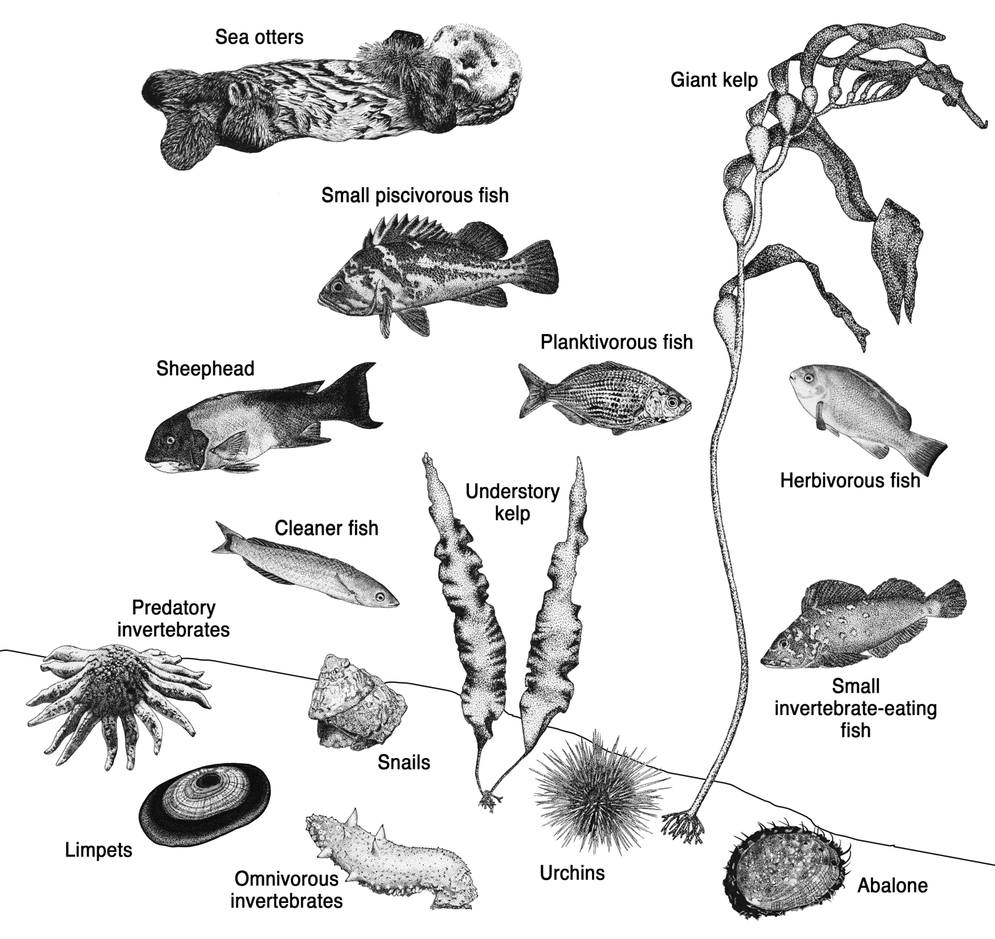

**Fig. 1.** **A graphical depiction of the kelp forest community groups considered in the analysis**. See Table S1 for complete list of all species included in each group. Note that organisms are not drawn to scale.

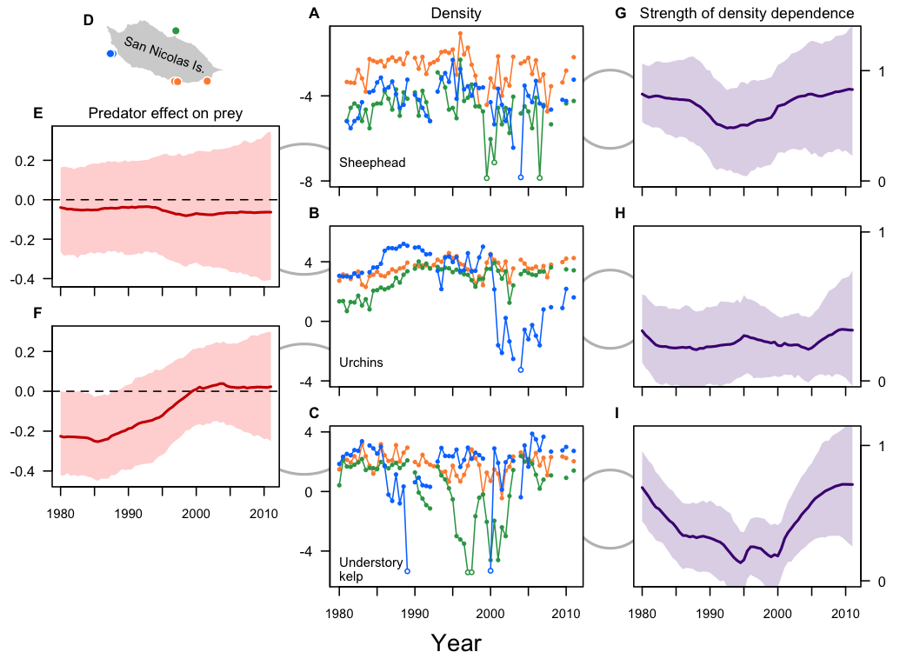

**Fig. 2.** C**hanges in density, predator-prey effects, and the strength of density dependence over time**. Average log-density of representative taxa including sheephead (**A**), urchins (**B**), and understory kelps (**C**) in three regions around San Nicolas Island (**D**) as indicated by green, orange, and blue. From the time series we estimated the effects of predators on prey (sheephead on urchins, **E**; urchins on kelp, **F**) and the strength of density dependence for sheephead (**G**), urchins (**H**), and kelps (**I**). Thick lines in (**E-I**) indicate the median effect and shaded region is the 90% credible region. Values in (**G-I**) greater than one indicate density-independent population growth. Gray arcs are meant to illustrate predator-prey interactions (left) and intraspecific competition (right).

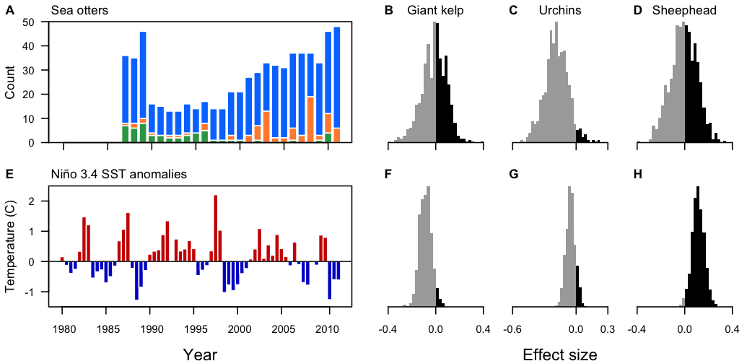

**Fig. 3.** **Time series of extrinsic drivers and their effects on different trophic levels**. Numbers of sea otters on San Nicolas Island from 1980-2011 (**A**) and their estimated effects on giant kelps (**B**), urchins (**C**), and sheephead (**D**); and the time series of El Niño/Southern Oscillation (ENSO) sea-surface temperature anomalies (**E**) and their effects on giant kelps (**F**), urchins (**G**), and sheephead (**H**). Colors in (**A**) correspond to sampling sites in Fig 2A.

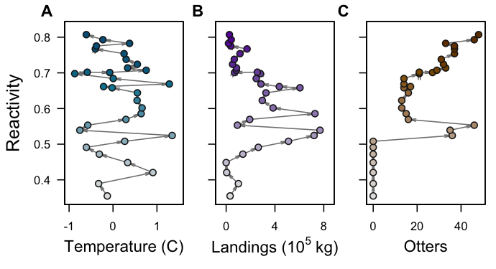

**Fig. 4.** **Relationship between reactivity and extrinsic drivers**. Phase-plane plots of reactivity against El Niño/Southern Oscillation (ENSO) sea-surface temperature anomalies (**A**), urchin landings (**B**), and otters (**C**). Shading indicates the passage of time from 1983 (light) through 2011 (dark). Original estimates for (**A**) and (**B**) were averaged within a year to make the results directly comparable to (**C**). Passage of time indicated by arrows and shading transition from light to dark.

**Table 1.** List of the six sampling sites and how they were grouped into the four different communities.

|  |  |  |  |
| --- | --- | --- | --- |
| From Kenner et al. (2013) | | |  |
| Site | Name | Region | Community |
| 1 | Nav Fac | North | 1 |
| 2 | Sandy Cove | West | 2 |
| 3 | West End | West | 2 |
| 4 | East Dutch Harbor | South | 3 |
| 5 | West Dutch Harbor | South | 3 |
| 6 | Daytona | South | 4 |